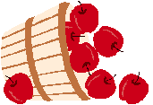
Barb’s Apple Cake
¼ cup shortening 1 C flour ½ tsp. cinnamon
1 egg ½ tsp nutmeg ½ tsp baking soda
1 tsp vanilla ½ tsp baking powder ½ tsp salt
3 cups diced peeled apples 1 C sugar

In a bowl cream shortening and sugar. Add egg and vanilla.
Combine flour, baking soda, baking powder, salt, cinnamon, and nutmeg. Stir in apples. Spoon into a greased 8” square pan.
Bake at 350º for 45-50 minutes or until a toothpick inserted near the center comes out clean.
Note: The mixture may be very dry when put into pan, but this is normal.
www.sagesapples.com

